PRODUCT INFORMATION FILE*

RégimA Company

Slimming Sculpting Solution Lift-Firm-Tone-Sculpt

Prepared: March 2019
(Label & packaging update August 2021)

*As required under Article 11 of the European Cosmetics Regulation EC No. 1223/2009
TABLE OF CONTENTS

Contents
INTRODUCTION 3
PRODUCT DESCRIPTION 3
COSMETIC PRODUCT SAFETY REPORT 7
Part A: Cosmetic Product Safety Information 7
A.1 Quantitative and qualitative composition of the cosmetic product: 7
A.2 Physical /chemical characteristics and stability of the cosmetic product 11
A.3 Microbiological Quality 12
A.4 Impurities, traces, information about the packaging material 12
A.5 Normal and reasonably foreseeable use 12
A.6 Exposure to the Cosmetic Product 12
A.7 Exposure to the Substances 13
A.8 Toxicological Profile of the Substances 15
A.9 Undesirable Effects and Serious Undesirable Effects 19
A.10 Information on the Cosmetic Product 19
B: Part Cosmetic Product Safety Assessment 20
B.1 Assessment Conclusion 20
B.2 Label Warnings and Instructions for Use 20
B.3 Reasoning 21
B.4 Assessors Credentials and Approval of Part B 21
List of References 21
METHOD OF MANUFACTURE / GMP CERTIFICATION 22
PROOF OF EFFECT CLAIMED 23
ANIMAL TESTING STATEMENT 23
Appendix 1: Safety Data Sheets or Ingredient Specifications 24
Appendix 2: Microbial Challenge Test 25
Appendix 3: Certificates of Allergen Content 26
Appendix 4: Miscellaneous 27

INTRODUCTION

PRODUCT DESCRIPTION

Product Name: Slimming Sculpting Solution Lift-Firm-Tone-Sculpt

Product type | Body Cream
Form | Cream
Colour | Off White
Pack size | 100ml and 200ml
Pack type | Chubby Chunky Airless Container
Dispenser type | Polypropylene pump
Part of a set | No
Manufacturer code | BSS 002
Normal use | Directions for use:  200ml Box  To be used as part of a RégimA in-salon treatment.  Cleanse the body of cream and oil, except SpaZone O₂-Purifyer Serum and/or Target Cellulite, which may be used in combination.  Apply one pump depression per target area such as thighs, inner knees, abdomen, upper arms. Gently massage a thin layer of cream solution to target areas. A cooling sensation may be felt. Therapist may then apply plastic wrap firmly over treated areas and leave for one hour. Plastic wrap is then removed.  These SpaZone products are leave on treatments that work synergistically so are not cleansed off until the next morning if possible.

Pictures of the Item: On following page
Container label

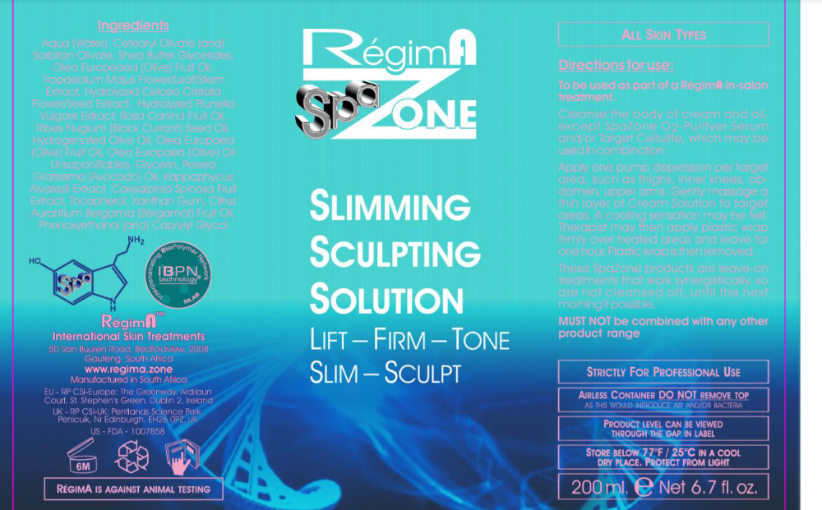
Carton label

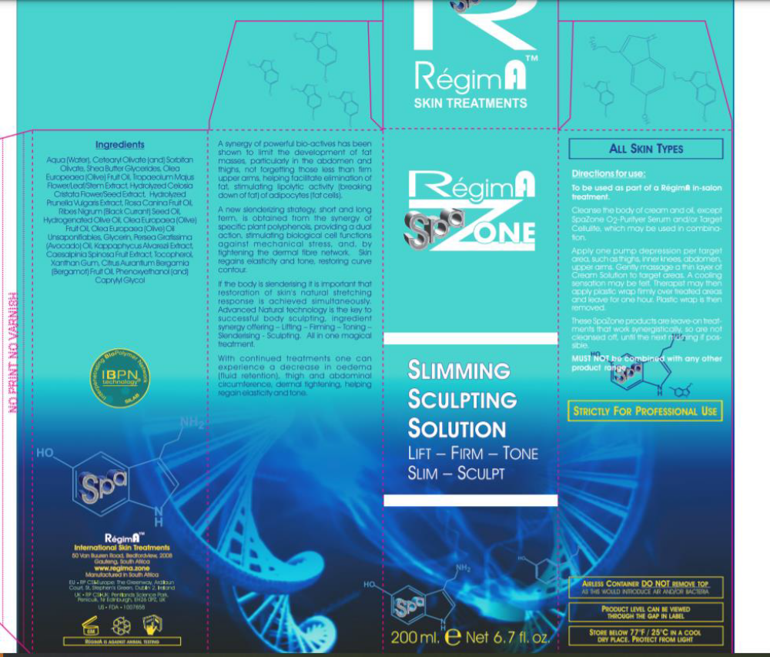

Batch code: The batch number is printed onto the underside of the carton and the container at the point of manufacturing and filling, therefore it is not visible on the label as represented in this PIF. The batching is automated, so the batch code and date is printed onto the carton and container as they are filled and boxed.

Product claims:

This product claims to limit the development of fat masses, particularly in the abdomen and thighs and to firm the upper arms. It helps to facilitate the elimination of fat, stimulating lipolytic activity (breaking down of fat) of adipocytes (fat cells).

Provides a dual action mechanism by tightening the dermal fiber network, allowing the skin to regain elasticity and tone, restoring curve contour.

It has been described that with continued treatments the consumer can experience a decrease in oedema (fluid retention), thigh and abdominal circumference, dermal tightening, helping regain elasticity and tone.

COSMETIC PRODUCT SAFETY REPORT

Part A: Cosmetic Product Safety Information

A.1 Quantitative and qualitative composition of the cosmetic product:

Slimming Sculpting Solution Lift Firm Tone Sculpt base formula

No | Raw Ingredient (INCI Name) | % (w/w) | Mixture % w/w Wt(g/kg) | CAS | EC | Function | Supplier (Agent) | Tradename
1 | Cetearyl Olivate | 2.5 | 5 | 85116-80-9 | 285-532-3 | Emulsifying | Textron Tecnica (CJP Chemicals) | Olivem® 1000
1 | Sorbitan Olivate | 2.5 | 5 | 223706-40-9/  92202-01-2 | 296-0335-5 | Emulsifying | Textron Tecnica (CJP Chemicals) | Olivem® 1000
2 | Shea butter Glycerides | 5 | 5 | 194043-92-0/  68424-61-3 | 270-312-0 | Emulsifying | Textron Tecnica (CJP Chemicals) | Olivem® 1000
3 | Olea Europaea Fruit Oil | 5 | 5 | 8001-25-0 | 232-277-0 | Masking/  Perfuming/  Skin Conditioning | Textron Tecnica (CJP Chemicals) | Olive Oil Extra Virgin
4 | Water (Aqua) | 3.38 | 4 | 7732-18-5 | 231-791-2 | Solvent/  Skin Conditioning/  Abbrasive/  Bulking | Silab (Meganede) | Coheliss™
4 | Pentylene Glycol | 0.4 | 4 | 5343-92-0 | 226-285-3 | Solvent/  Skin Conditioning/  Abbrasive/  Bulking | Silab (Meganede) | Coheliss™
4 | Secale Cereale Seed Extract | 0.22 | 4 | 90106-48-2 | 290-271-3 | Solvent/  Skin Conditioning/  Abbrasive/  Bulking | Silab (Meganede) | Coheliss™
5 | Water (Aqua) | 3.464 | 4 | 7732-18-5 | 231-791-2 | Solvent/  Skin Conditioning/  Skin Protecting | Silab (Meganede) | BioSculptine® s GR
5 | Pentylene Glycol | 0.4 | 4 | 5343-92-0 | 226-285-3 | Solvent/  Skin Conditioning/  Skin Protecting | Silab (Meganede) | BioSculptine® s GR
5 | Hydrolyzed Celosia Cristata Flower/Seed Extract | 0.1088 | 4 | 669066-11-9 | 613-997-8 | Solvent/  Skin Conditioning/  Skin Protecting | Silab (Meganede) | BioSculptine® s GR
5 | Hydrolyzed Prunella Vulgaris Extract | 0.0272 | 4 | 90105-92-3 | 290-211-6 | Solvent/  Skin Conditioning/  Skin Protecting | Silab (Meganede) | BioSculptine® s GR
6 | Rosa Canina Fruit Oil | 3 | 3 | 84603-93-0/  84696-47-9 | 238-652-0 | Emollient/  Skin Conditioning | Seatons (Croda) | Seatons Rosehip Oil Ref-LQ-(JL)
7 | Ribes Nigrum Seed Oil | 3 | 3 | 68606-81-5/  97676-19-2 | 271-749-0 | Emollient | Textron Tecnica (CJP Chemicals) | Blackcurrent Seed Oil
8 | Hydrogenated Olive Oil | 1.95 | 3 | 226993-75-5/  68334-28-1 | 269-820-6/ | Skin Conditioning/  Viscosity Controlling/  Masking/  Perfuming | Textron Tecnica (CJP Chemicals) | Oliwax®
8 | Olea Europaea Fruit Oil | 0.825 | 3 | 8001-25-0 | 232-277-0 |  | Textron Tecnica (CJP Chemicals) | Oliwax®
 | Olea Europaea Oil Unsaponifiables | 0.225 | 3 | 8001-25-0/  798-12-8 | 232-277-0 |  | Textron Tecnica (CJP Chemicals) | Oliwax®
9 | Glycerin | 3 | 3 | 56-81-5 | 200-289-5 | Humectant/  Perfuming/  Skin Protecting/  Viscosity Controlling | Various | Refined Glycerine
10 | Persea Gratissima Oil | 2 | 2 | 8024-32-6 | 232-428-0 | Skin Conditioning | Textron Tecnica (CJP Chemicals) | Cold Pressed refined Avocado Oil
11 | Phenoxyethanol | 0.9 | 1 | 122-99-6 | 204-589-7 | Preservative/  Emollient/  Humectant/  Skin Conditioning | Dr. Strartmans (Meganede) | Verstatil® PC
11 | Caprylyl Glycol | 0.1 | 1 | 117-86-8 | 214-254-7 | Preservative/  Emollient/  Humectant/  Skin Conditioning | Dr. Strartmans (Meganede) | Verstatil® PC
12 | Water (Aqua) | 0.05 | 1 | 7732-18-5 | 231-791-2 | Solvent/  Skin Conditioning | Silab (Meganede) | Filmexel®
12 | Kappaphycus Alvarezii extract | 0.475 | 1 | 1220882-73-4 | 310-127-6 | Solvent/  Skin Conditioning | Silab (Meganede) | Filmexel®
12 | Caesalpinia Spinosa Fruit pod extract | 0.475 | 1 | 39300-88-4 | 254-409-6 | Solvent/  Skin Conditioning | Silab (Meganede) | Filmexel®
13 | D-Limonene | 0.2735 | 1 | 5989-27-5 | 227-813-5 | Perfuming/  Masking/  Antifoaming | FD Copeland (CJP Chemicals) | Bergamot Oil
13 | Linalyl Acetate | 0.5379 | 1 | 115-95-7 | 204-116-4 | Perfuming/  Masking/  Antifoaming | FD Copeland (CJP Chemicals) | Bergamot Oil
13 | Linalool | 0.1005 | 1 | 78-70-6 | 201-134-4 | Perfuming/  Masking/  Antifoaming | FD Copeland (CJP Chemicals) | Bergamot Oil
13 | Citral | 0.0301 | 1 | 5392-40-5 | 226-394-6 | Perfuming/  Masking/  Antifoaming | FD Copeland (CJP Chemicals) | Bergamot Oil
13 | Gamma-Terpinene | 0.029 | 1 | 99-85-4 | 202-794-6 | Perfuming/  Masking/  Antifoaming | FD Copeland (CJP Chemicals) | Bergamot Oil
13 | Pinene | 0.029 | 1 | 80-56-8 | 201-291-9 | Perfuming/  Masking/  Antifoaming | FD Copeland (CJP Chemicals) | Bergamot Oil
14 | Xanthan Gum | 0.25 | 0.25 | 11138-66-2 | 234-394-2 | Binding/  Emulsifying/  Smulsion Stabilising/  Gel Forming/  Skin Conditioning/  Surfactant/  Viscosity Controlling | CP Kelco (Tranarc) | Keltrol T-Plus
15 | Tocopherol | 0.1 | 0.1 | 54-28-4 (gamma)/  166698-35-4 (beta)/  10191-41-0(DL)/  119-13-1/  1406-18-4/  14066-66-2/  2074-53-5(DL)/  59-02-9(D)/  7616-22-0 | 200-201-5/  240-747-1/  233-466-0/  204-299-0/  215-798-8/  218-197-9/  200-412-2 | Antioxidant/  Masking/  Skin Conditioning | DL-α-Tocopherol | DSM nutritional products (Chempure)
16 | Water (Aqua) | 59.65 | 59.65 | 7732-185 | 231-791-2 | Solvent | In House | Deionised water
# not assigned

Ingredient order for the label: Water (Aqua), Olea Europaea Fruit Oil, Shea Butter Glycerides, Glycerin, Ribes Nigrum Seed Oil, Rosa Canina Fruit Oil, Cetearyl Olivate, Sorbitan Olivate, Persea Gratissima Oil, Hydrogenated Olive Oil, Citrus bergamia peel Oil expressed, Phenoxyethanol, Pentylene Glycol, Caesalpinia Spinosa Fruit Pod extract, Kappaphycus Alvarezii Extract, Limonene, Xanthan Gum, Olea Europaea Oil Unsaponifiables, Secale Cereale Seed Extract, Hydrolyzed Celosia Cristata Flower/Seed Extract, Linalool, Caprylyl Glycol, Tocopherol, Citral, Hydrolyzed Prunella Vulgaris Extract , Alpha-Pinene, Linalyl Acetate.
Red font denotes ingredients present at less than 1% which may be listed in any order.
Below are the allergens and their respective concentrations in the fragrance that are required to be listed in Article 19 Paragraph 1(d) & (g (ii)) of EC 1223/2009 when present at levels >0.001% in a leave-on product.

Fragrance allergens

INCI (EU) Name | CAS number | EC number | Concentration % w/w | Reference
Alpha -pinene | 80-56-8 | 201-291-9 | 0.029 | SCCS opinion on Fragrance allergens in cosmetic products, medium risk allergen *
Linalyl Acetate | 115-95-7 | 204-116-4 | 0.5379 | SCCS opinion on Fragrance allergens in cosmetic products, low risk allergen *
Citral | 5392-40-5 | 226-394-6 | 0.0301 | Annex III/70 2*
Limonene | 5989-27-5 | 227-813-5 | 0.2795 | Annex III/88 2*
Linalool | 78-70-6 | 201-134-4 | 0.1005 | Annex III/84 2*
The restrictions of the fragrance allergens relate to the following sources:
* SCCS Opinion on Fragrance allergens in cosmetic products, SCCS/1459/11.
2* Regulation (EC) No. 1223/2009 of the European parliament and of the council of 30 November 2009 on cosmetic products, Annex III List of substances which cosmetic products must no contain except to the restrictions laid down, L342/128.

A.2 Physical /chemical characteristics and stability of the cosmetic product

Physical and chemical characteristics of the ingredients have been listed in the safety data sheets which are maintained electronically by the Responsible Person and are available on request. A cross reference to the SDS tradename and electronic reference number has been shown in the base formula table.

Physical and Chemical Characterization of the product

1 Physical state | Cream
2 type of mixture (emulsion/ o/w or w/o, suspension, lotion, powder, aerosol …) | w/o
3 organoleptic properties (colour, odour, whenever relevant) | Off white cream, characteristic Bergamot odour
4 pH (at 25ºC) | 4.43
5 viscosity (at 25ºC ) | 19,000 cPs
6 thermal stability (glass bottle) | 40°C for 12 weeks
7 Specific gravity (at 25ºC) | 0.961/ml

Stability of the product

A shelf-life of 6 months after opening has been allocated to this product.

An on-going stability study of the product in the packaging will be available to support the shelf-life. A stability test of the product in glass jars has confirmed stability at 25ºC for 12 weeks. During the test period the viscosity had significantly increased by 21%.

Additional testing was performed at 5°C, 40°C and 50°C over a 12 week period.

5°C Stability testing
During stability testing at 5ºC at the week 12 time point the appearance of the product was described as having oily globules. An 44% increase in viscosity was also noted.

40°C Stability testing
Accelerated stability testing at 40ºC showed changes in the product appearance at week 12 where it was noted as having ‘oily globules’. Additionally, in week 12, the odour was noted to have changed where it was described as ‘slightly stronger base odour’ and the pH had dropped by 21%.

50°C Stability testing
A slight yellowish appearance change was noted from week 2 to 8 when the product was tested at 50°C, with the appearance noted as separating on week 12.

The pH had notably changed in week 2 where there was a 14% drop, this decrease continued through to week 12 where there was a 29% decrease. Additionally during viscosity testing there was a change noted from week 1 there was a 43% increase additional changes were noted in week 4, 8 and 12 where the changes were 49%, 20% and 40% respectively
.
A label warning is in place to store Slimming Sculpting Solution-Lift-Firm-Tone-Sculpt at a temperature of 25°C, with this it is not expected to affect the stability of the product as formulated.

A.3 Microbiological Quality

A PET test has been performed according to USP method 38 and confirms the effectiveness of the preservative for a period of 28 days. The certificate has been presented in Appendix 2.

A.4 Impurities, traces, information about the packaging material

None of the ingredients of this product contained impurities at a level which would require notification.

A statement on the suitability of the product packaging is shown below.

The Airless Chubby Chunky Containers used in the 100ml slimming sculpting solution are made from Polypropylene and Low-density Polyethylene (LDPE), the pump is LDPE. The Airless Chubby Chunky Containers used in the 200ml slimming sculpting solution are made from Polypropylene with the pump being made from LDPE and High-density Polyethylene (HDPE). The components of the packaging material and suitability of use criteria are included in Appendix 4. This is maintained electronically with the PIF by the Responsible Person and is available on request.

A.5 Normal and reasonably foreseeable use
Slimming Sculpting Solution Lift-Firm-Tone-Sculpt is a product designed to limit the development of fat masses, helping facilitate the elimination of fat, stimulating lipolytic activity (breaking down of fat) of adipocytes (fat cells) . It is a leave-on product that in normal circumstances will be used once daily on the thighs, inner knees, abdomen and upper arms.

A.6 Exposure to the Cosmetic Product

Site of application | Total body area (Area body -Area head female)
Surface area of application (cm²) | 15670*
Volume of product applied (mg) | 7820**
Frequency of application/use per day | Once daily
Target population | Adults
Normal and foreseeable exposure route | Dermal
Calculated relative daily exposure according to SCCS notes for guidance tables (mg/kg bw/day) | 7.82g used once daily on a 60kg person, Relative Daily Exposure has been calculated as 130.33 mg/kg bw/day
Dermal absorption information | None
other | NA
* Surface area of application has been established as 15670cm², taking worst case scenario of RégimA Slimming Sculpting Solution Lift-Firm-Tone-Sculpt being applied to the entire body during one treatment session. Area body – Area head female = 15670cm². Table 1; Mean exposed skin surface area per product type and frequency of application per product type, Section 4-2, page 76, SCCS Notes of guidance for the testing of cosmetic ingredients and their Safety Evaluation, 9th revision.
** Volume of product applied = 7820mg; taken as worst case scenario of application of product to the entire body. Volume of product applied has been extracted from Skin Care, Body lotion, Table 2: Estimated daily exposure levels for different cosmetic product types according to Cosmetics Europe Data, SCCS Notes of Guidance for the testing of Cosmetic Ingredients and their Safety evaluation, 9th revision.

A.7 Exposure to the Substances

Daily Systemic Exposure Dosage (SED) is the daily amount of a cosmetic substance applied based on the concentration of that particular substance, the percutaneous absorption and the nominal human body weight (60 kg) and this is shown in the table below.
Ingredient  (INCI name & CAS number) | Maximum concentration  (%) | Calculated product relative daily exposure (mg/kg bw/day) | Dermal penetration factor# | Daily ingredient exposure or SED  (mg/kg bw/day)
Olea Europaea Fruit Oil  8001-25-0 | 5.825 | 130.33 | 1 | 7.5917
Shea butter Glycerides  194043-92-0 | 5 | 130.33 | 1 | 6.5165
Glycerin  56-81-5 | 3 | 130.33 | 1 | 3.9099
Ribes Nigrum Seed Oil  68606-81-5 | 3 | 130.33 | 1 | 3.9099
Rosa Canina Fruit Oil  84603-93-0 | 3 | 130.33 | 1 | 3.9099
Cetearyl Olivate  85116-80-9 | 2.5 | 130.33 | 1 | 3.2583
Sorbitan Olivate  223706-40-9 | 2.5 | 130.33 | 1 | 3.2583
Persea Gratissima Oil  8024-32-6 | 2 | 130.33 | 1 | 2.6066
Hydrogenated Olive Oil  226993-75-5 | 1.95 | 130.33 | 1 | 2.5414
Citrus bergamia peel oil expressed  93686-22-7 | 1 | 130.33 | 1 | 1.3033
Phenoxyethanol  122-99-6 | 0.9 | 130.33 | 1 | 1.1730
Pentylene Glycol  5343-92-0 | 0.8 | 130.33 | 1 | 1.0426
Caesalpinia Spinosa Fruit pod extract  39300-88-4 | 0.475 | 130.33 | 1 | 0.6191
Kappaphycus Alvarezii extract  1220882-73-4 | 0.475 | 130.33 | 1 | 0.6191
Xanthan Gum  11138-66-2 | 0.25 | 130.33 | 1 | 0.3258
Olea Europaea Oil Unsaponifiables  8001-25-0 | 0.225 | 130.33 | 1 | 0.2932
Secale Cereale Seed Extract  90106-48-2 | 0.22 | 130.33 | 1 | 0.2867
Hydrolyzed Celosia Cristata Flower/Seed Extract  669066-11-9 | 0.1088 | 130.33 | 1 | 0.142
Caprylyl Glycol  117-86-8 | 0.1 | 130.33 | 1 | 0.130
Tocopherol  54-28-4 | 0.1 | 130.33 | 1 | 0.130
Hydrolyzed Prunella Vulgaris Extract  90105-92-3 | 0.0272 | 130.33 | 1 | 0.0354
# No dermal absorption data is available, 100% dermal absorption assumed as it is a leave on product.

A.8 Toxicological Profile of the Substances
Ingredient  (INCI name & CAS number) | Hazard ID and listª | Reference for hazard ID | Irritant to eyes | Irritant to skin | Sensitiser | Human data | NOAEL  (mg/kg bw/day) | SED^{b} | MoS^{c} | comment
Olea Europaea Fruit Oil  8001-25-0 | A | 2014 CIR Compendium. For use up to 100%, Final report 03/11 available from CIR. Present in the current formulation at 5.825% and is therefore considered safe for use.
Shea butter Glycerides  194043-92-0 | A | For use up to 6.5%, Final report 09/12/2017 available from CIR. Present in the current formulation at 5% and is therefore considered safe for use.
Glycerin  56-81-5 | A | Safe, GRAS, FDA approved food additive, FDA approved over the counter (OTC) for skin.
Ribes Nigrum Seed Oil  68606-81-5 | A | 2014 CIR Compendium. For use up to 0.3%, Final report 03/11 available from CIR. Ribes Nigrum Seed Oil is present in Slimming Sculpting Solution-Lift-Firm-Tone-Sculpt at 3%. A dermal irritation and sensitization study was performed using a skin cream containing 0.2% Ribes Nigrum (Blackcurrant) oil was evaluated with 106 participants in a HRIPT with an occlusive patch. The test indicated that it was not a dermal irritant or a sensitizer. Ribes Nigrum at 0.25% was formulated in a cream (type not specified) which was evaluated on 119 participants to determine Primary cutaneous irritation the results showed no primary irritation . Ribes Nigrum (Blackcurrant) seed oil is also a food item; GRAS, it is therefore considered safe for use in Slimming Sculpting Solution-Lift-Firm-Tone-Sculpt.
Rosa Canina Fruit Oil  84603-93-0 | A | 2014 CIR Compendium. For use up to 19%, final report 03/11 available from CIR. Present in the current formulation at 3% and is therefore considered safe for use.
Cetearyl Olivate  85116-80-9 | A | 2014 CIR Compendium. For use up to 3% and when formulated to be non-irritating, Final report 03/2013 available from CIR. Present in the current formulation at 2.5% and is therefore considered safe for use.
Sorbitan Olivate  223706-40-9 | A | 2014 CIR Compendium. For use up to 7.5%, IJT 21(S1):93-112, 2002. Present in the current formulation at 2.5% and is therefore considered safe for use.
Persea Gratissima Oil  8024-32-6 | A | 2014 CIR Compendium. For use up to 89%, Final amended report 03/11 available from CIR; JEPT 4(4):93-103, 1980 (original) re-review IJT 22(S1) :1-35, 2003. Present in the current formulation at 2% and is therefore considered safe for use.
Hydrogenated Olive Oil  226993-75-5 | A | 2014 CIR Compendium. For use up to 12%, Final report 03/11 available from CIR. Present in the current formulation at 1.95% and is therefore considered safe for use.
Phenoxyethanol  122-99-6 | A | 2014 CIR Compendium. For use up to 1%, JACT 9(2):259-77,1990. Present in the current formulation at 0.9% and is therefore considered safe for use.
Pentylene Glycol  5343-92-0 | A | 2014 CIR Compendium. For use up to 5%, IJT 31 (S2):147-168, 2012. Present in the current formulation at 0.8% and is therefore considered safe for use.
Caesalpinia Spinosa Fruit pod extract  39300-88-4 | ## | A secondary assessment was performed on Caesalpinia Spinosa Fruit Pod extract. A recommended dose was established as 1-5%; where 5% was used as the worst case scenario dose. Caesalpinia Spinosa Fruit Pod extract is present in Slimming Sculpting Solution lift-Firm-Tone-Sculpt at 0.475%, 10.5 times lower than that of the worst case dose outlined. A read across to Caesalpinia Spinosa gum was performed due to the gum being derived from the dried, gummy exudate of Caesalpinia Spinosa leuminosae. Caesalpinia Spinosa gum has been approved for use as a food ingredient with no specific ADI for man established. 2014 CIR Compendium has outlined a use concentration of 0.5% for Caesalpinia Spinosa gum (Final report 03/12 available from CIR). It’s present in the current formulation at 0.475% and is therefore considered safe for use.. Caesalpinia Spinosa Fruit pod extract is not expected to cause any adverse outcome effects in Slimming Sculpting Solution lift-Firm-Tone-Sculpt as formulated when used as directed.
Kappaphycus Alvarezii extract  1220882-73-4 | ## | A secondary assessment was performed on Kappaphycus Alvarezii extract. A read across was performed to Carrageenan as the primary component of Kappaphycus Alvarezii is sulfonated galactans knowns as Carrageenan. Carrageenan is GRAS the US FDA and is an approved food additive. The WHO JECFA report established confirmed that carrageenan is safe for food use and concluded that it is not necessary to specify an ADI. The carrageenan molecule is a large molecule with average molecular weights of 200,000-400,000 leading to a low dermal absorption potential and therefore reducing the risk of a systemic effect. It was therefore concluded that the presence of Kappaphycus Alvarezii extract in Slimming Sculpting Solution Lift-Firm-Tone-Sculpt at 0.475% is not expected to cause an adverse outcome effect when used as directed.
Xanthan Gum  11138-66-2 | A | 2014 CIR Compendium. For use up to 6%, Final report 09/12 available from CIR. Present in the current formulation at 0.25% and is therefore considered safe for use.
Olea Europaea Oil Unsaponifiables  8001-25-0 | A | 2014 CIR Compendium. For use up to 3%, Final report 03/11 available from CIR. Present in the current formulation at 0.225% and is therefore considered safe for use.
Secale Cereale Seed Extract  90106-48-2 | A | The common name for Secale Cereale Seed Extract is Rye Seed Extract. Rye seeds are a common food ingredient with no safety concerns associated with it. It was determined that Secale Cereale Seed Extract is not expected to cause any adverse outcomes when used as directed, at 0.22% (0.0092 mg/kg bw/day).
Hydrolyzed Celosia Cristata Flower/Seed Extract  669066-11-9 | ## | A secondary assessment of Hydrolyzed Celosia Cristata Flower/Seed Extract has been performed. It has been used in traditional medical for the purposes of headaches, ulcers and eye inflammation. Limited toxicological data is available however an oral administration study where a methanol extract of Celosia Cristata was administered in feed at doses of between 1000-4000 mg/kg which equated to 150-600 mg/kg bw/day with a conversion factor was applied. Hydrolyzed Celosia Cristata Flower/Seed Extract is present in Slimming Sculpting Lift-Firm-Tone-Slim-Sculpt at 0.142 mg/kg bw/day; 1056 –4225 times lower than the doses previously outlined. Hydrolyzed Celosia Cristata Flower/Seed Extract is a component of Silab® product marketed as Biosculptine, the combined safety has been examined and was confirmed as both non-irritating in cutaneous irritation tests in vivo on human volunteers and non-sensitizing following evaluation in human volunteers using the Marzulli-Maibach method, these studies are outlined in the Biosculptine leaflet in Appendix 4. It is therefore concluded that Hydrolyzed Celosia Cristata Flower/Seed Extract is not expected to cause any adverse outcomes when used as directed, in Slimming Sculpting Lift-Firm-Tone-Slim-Sculpt as formulated.
Caprylyl Glycol  117-86-8 | A | 2014 CIR Compendium. For use up to 5%, IJT 31 (S2):147-168, 2012. Present in the current formulation at 0.1% and is therefore considered safe for use.
Tocopherol  54-28-4 | A | 2014 CIR Compendium. For use <=5%, IJT 21(S3):51-116, 2002; Final report 03/2014 available from CIR. Present in the current formulation at 0.1% and is therefore considered safe for use.
Hydrolyzed Prunella Vulgaris Extract  90105-92-3 | ## | A secondary assessment has been performed on Hydrolysed Prunella Vulgaris extract. Limited toxicological data was available with a dose range of 0.75g to 30g established via oral administration and topical application. Hydrolysed Prunella Vulgaris extract is present in Slimming Sculpting Solution Lift-Firm-Tone-Sculpt at 0.0354 mg/kg bw/day. The systemic exposure was calculated to be 12.5 mg/kg bw/day and 500mg/kg bw/day based on a 60kg human which equated to 353 and 14124 times greater than that outlined in formulation for 0.75g (750mg) and 30g (30,000mg) respectively. Prunella Vulgaris is a common Chinese herbal medicine that is used to treat a range of illnesses that include high blood pressure. Prunella Vulgaris has been listed on the FDA Poisonous Plant Database, it was also found that small doses of Prunella Vulgaris is considered safe. Hydrolyzed Prunella Vulgaris Extract is a component of Silab® product marketed as Biosculptine, the combined safety has been stated as non-irritating in cutaneous irritation tests when used between 2 and 4% in human volunteers. Along with the irritation potential being evaluated the sensitizing potential was evaluated and resulted in a non-sensitizing affirmation following its evaluation in vivo on human volunteers using the Marzulli-Maibach method, this is presented in the Biosculptine leaflet presented in Appendix 4. As hydrolyzed Purnella Vulgaris is present in Slimming Sculpting Solution Lift-Firm-Tone-Sculpt at a low level (0.0272%) and considering the available safety information, it is not expected that there would be adverse effects and it is expected to be safe for use when used as directed.

ª Some ingredients are excluded from a formal risk assessment where a recognized authority has published a review of the ingredient under similar conditions of use and concluded on safe use at the level of inclusion in the cosmetic product (Hazard ID=A). Hazard ID category B is for recognized authority reviews of the ingredient under similar conditions of use with restricted use or where the ingredient is contained in the annexes to Regulation (EC) No 1223/2009 (Hazard ID=B). Where hazard ID A or B is reported, the maximum allowed usage concentration should be stated.
^{b} all possible routes of exposure should be considered
^{c} A MoS of greater than 100 is considered to represent safe use
# Food item, hazard and exposure data not required.
## Secondary assessment performed and report presented in Appendix 4.

Fragrances:

Slimming Sculpting Solution Lift-Firm-Tone-Sculpt contains the fragrance Citrus Bergima Peel Oil expressed, known as Bergamot Oil. The IFRA certificate is presented in Appendix 3 and fragrance allergen composition is outlined in Section A.1.

A.9 Undesirable Effects and Serious Undesirable Effects

No undesirable effects are anticipated based on the product being used as directed on the total body area, once daily.

A.10 Information on the Cosmetic Product

Slimming Sculpting Solution Lift-Firm-Tone-Sculpt was released in July 2017. Over the period July 2017 to October 2018 , 346 units have been sold and there have been no adverse reactions reported to RégimA Company.

B: Part Cosmetic Product Safety Assessment

B.1 Assessment Conclusion

Review of the ingredients

After analysis of all the available information including:
- formulation
- toxicological profile of the ingredients and their concentration in the product
- Product data sheets supplied by the ingredient manufacturer

It is not expected that Slimming Sculpting Solution Lift-Firm-Tone-Sculpt will cause damage to human health when used as directed.

It is therefore concluded that Slimming Sculpting Solution Lift-Firm-Tone-Sculpt can placed on the market in the EU as a body cream.

Review of human data on the product

There are no human tests such as a patch test, for this product.

B.2 Label Warnings and Instructions for Use

Directions for use are given on the product label and (Appendix 4).

Directions:
100ml Box
Cleanse the body of cream and oil, except SpaZone Target Cellulite, which may be used in combination.

Apply one pump depression per target area, such as thighs, inner knees, abdomen, upper arms. Gently massage a thin layer of cream solution to target areas. A cooling sensation may be felt.

These SpaZone products are leave-on treatments that work synergistically, so do not cleanse off until the next morning if possible.

200ml Box
To be used as part of a RégimA in-salon treatment.

Cleanse the body of cream and oil, except SpaZone O₂-Purifyer Serum and/or Target Cellulite, which may be used in combination.

Apply one pump depression per target area such as thighs, inner knees, abdomen, upper arms. Gently massage a thin layer of cream solution to target areas. A cooling sensation may be felt. Therapist may then apply plastic wrap firmly over treated areas and leave for one hour. Plastic wrap is then removed.

These SpaZone products are leave on treatments that work synergistically so are not cleansed off until the next morning if possible.
A IBPN technology® label is attached to packaging indicating that RégimA hold the license to utilize Silab’s Interpenetrating biopolymer Network in their cosmetics. The certificate stating this is presented in Appendix 4.

Warnings:
100ml
‘Must not be combined with any other product range’

‘A cooling sensation may be felt’

‘Airless Container DO NOT remove top as this would introduce air and/or bacteria’

‘Product level can be viewed through the gap in the label’

‘Store below 77°F/25°C in a cool dry place. Protect from light’

‘If irritation occurs, discontinue use’

200ml
‘To be used as part of RégimA in-salon treatment’

‘Must not be combined with any other product range’

‘A cooling sensation may be felt’

‘Strictly for professional use’

‘Airless Container DO NOT remove op as this would introduce air and/or bacteria’

‘Product level can be viewed through the gap in the label’

‘Store below 77°F/25°C in a cool dry place. Protect from light’

‘If irritation occurs, discontinue use’
B.3 Reasoning

This product contains many ingredients with a positive reputation for their body lotion properties and with good local tolerance. There are no reasons to anticipate tolerance problems with use.

This product is intended for external use in adults only.

B.4 Assessors Credentials and Approval of Part B

Shirley Hudson (safety assessor)
BSc, University of Aberdeen
CBiol, MSB
20+ years as a practicing toxicologist in the pharmaceutical and chemical industries
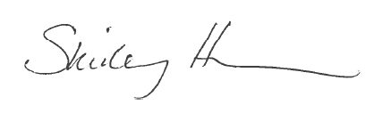

After analyzing of all of the available information including the product formulation and toxicological profile of the ingredients, I conclude that according to the current state of scientific knowledge, this product is not expected to result in any significant damage to human health and can be safely marketed for the intended and foreseeable use as a body lotion.

List of References

SCCS Notes of Guidance for the Testing of Cosmetic Substances and Their Safety Evaluation, 9th Revision, 29 September 2015 (SCCS/1564/15)
European Commission database on cosmetic ingredients (Cosing) http://ec.europa.eu/consumers/cosmetics/cosing/
Cosmetic ingredient review http://www.cir-safety.org/

METHOD OF MANUFACTURE / GMP CERTIFICATION

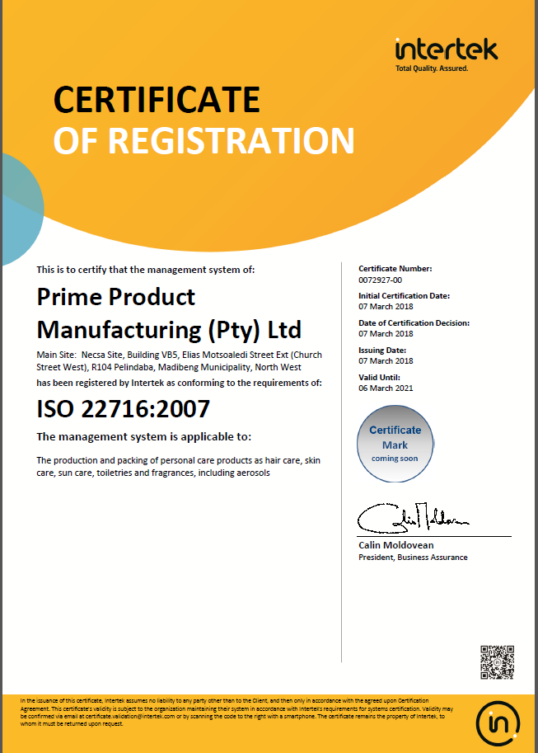

PROOF OF EFFECT CLAIMED

This product claims to limit the development of fat masses, particularly in the abdomen and thighs, firm upper arms, helping facilitate elimination of fat, stimulating lipolytic activity (breaking down of fat) of adipocytes (fat cells).

A new slenderizing strategy, short and long term, is obtained from the synergy of specific plant polyphenols, providing a dual action mechanical stress and by tightening the dermal fiber network. Skin regains elasticity and tone, restoring curve contour.

With continued treatments one can experience a decrease in oedema (fluid retention), thigh and abdominal circumference, dermal tightening, helping regain elasticity ad tone.

The claims relating to Slimming Sculpting Solution -Lift-Firm-Tone-Sculpt are substantiated by supplemented data supplied by Silab. RégimA is a licensed user of Silab products which include Biosculptine®, Coheliss and Filmexel where through In Vitro and human In Vivo testing have shown to substantiate the results claimed.

The additional information on Silab® ingredients are located in Appendix 4.

ANIMAL TESTING STATEMENT

To the best of our knowledge, the manufacturer and his suppliers have not carried out or commissioned any animal testing for the purpose of developing new cosmetic products.

The statement below is a confirmation of the company policy:
RégimA Skin Treatments
CK92/05371/23
VAT No. 4590131043

Tel: 011 615 2869 or 011 622 7827
Fax: 011 616 8008
Cell: 0836537020
e-mail: jax@regima.com

POSTAL ADDRESS: PO BOX 9523 Edenglen 1613
PHYSICAL ADDRESS: 20 River Road Morninghill Bedfordview 2007 RSA

Animal Testing Compliance Statement

This letter is to serve as testimony as to the practice of animal testing, and confirm that RégimA Skin Treatments has not, nor will not engage in any practice that involves animal testing in any form.

RégimA Skin Treatments hereby confirms neither the manufacturer nor RégimA Skin Treatments itself have commissioned or carried out any form of animal testing during the course of product development. This applies to any and all activities performed as part of the development process, including, but not restricted to: R&D, stability testing, safety and toxicology assessments, suitability studies or any other facet related to the product’s development.

Appendix 1: Safety Data Sheets or Ingredient Specifications

Safety data sheets and technical data sheets for the ingredients are maintained electronically with the PIF by the Responsible Person. They are available on request.

Appendix 2: Microbial Challenge Test
A microbial challenge test is maintained electronically with the PIF by the Responsible Person. It is available on request.

Appendix 3: Certificates of Allergen Content

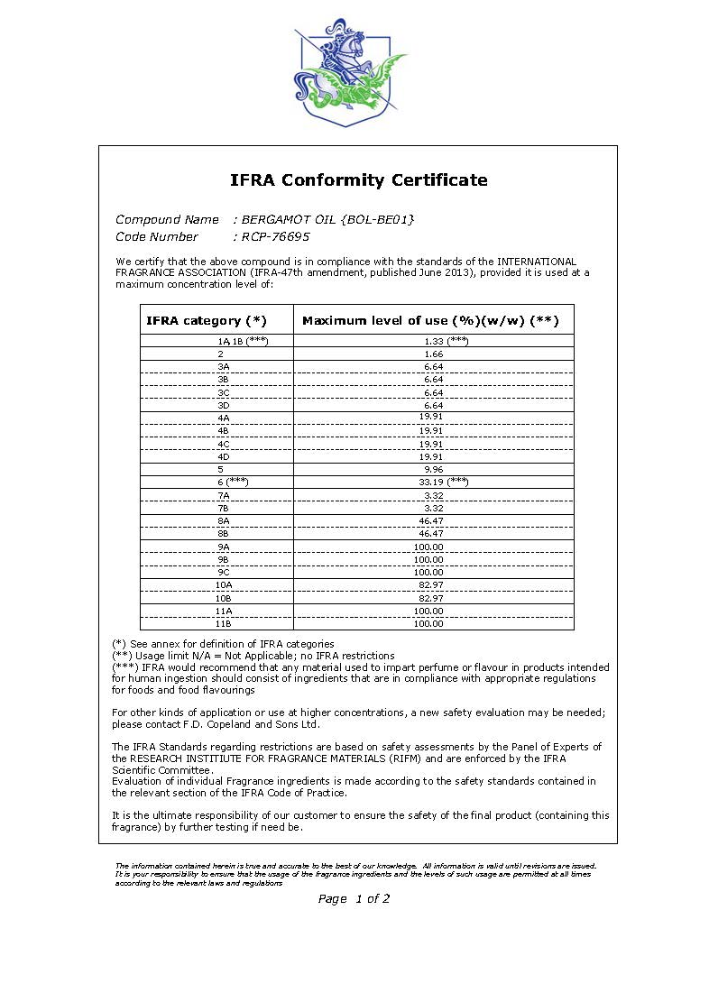

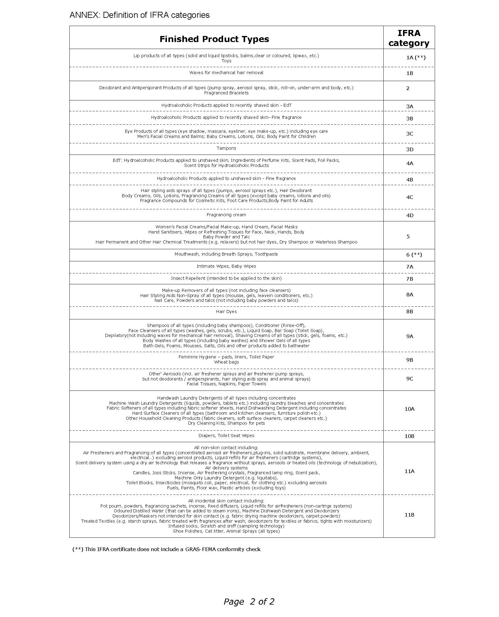

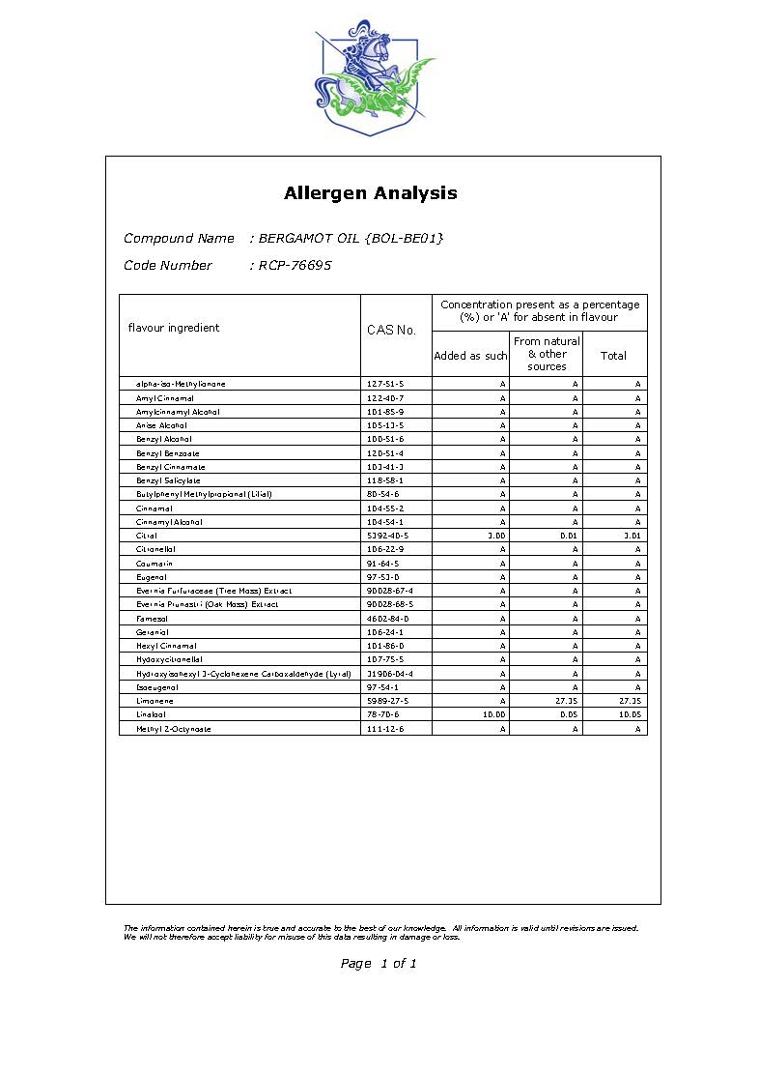

Appendix 4: Miscellaneous

The stability report, packaging material information and product carton insert are maintained electronically with the PIF by the Responsible Person. They are available on request.

